Coastal Empire Association

Coastal Empire Association is a member of the Georgia Federation of Saddle Clubs.
The Association participates in both Judged (Pleasure) and Timed (Running) Events under the following leadership

Timed Division
The timed division runs five total events broken down into seven age groups as outlined in the Federation Rules.
Earlene Burkhalter, President Jenna Harvey, Secretary
912-402-9672 912-486-6087
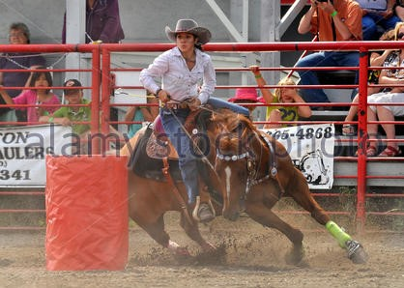

Judged Division
The judged division participants in Halter, Pleasure, Racking, Reining, and English events, also divided into specific age groups. The judged division may have different classes available from one year to the next.
Damon Kennedy, President
912-237-0419

