Deep Dixie Association

The Deep Dixie Association, a long standing member of the Georgia Federation of Saddle Clubs, offers both Pleasure and Running to it’s members. It is, however, a split group operating with two different set of Officers and timeframes for shows. We strive to have the shows on separate days so members or those wanting to join can participate in both disciplines, should they so choose. We are proud to have members from all over Southwest Georgia and North Florida.

Deep Dixie Pleasure
For more information- www.deepdixieclub.com or visit Deep Dixie Pleasure Horse Club on Facebook
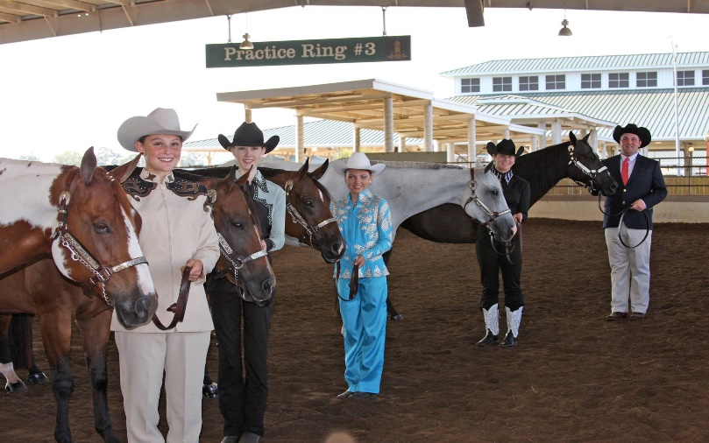
2020 Officers
President - Amanda Black
Vice President - Jeri Bennett
Shows are held at
Dougherty County Saddle Club – Albany
Bowlegs Arena – Shingler (Worth County)
Grady County Saddle Club – Cairo

Schedule and directions to Arenas
are provided on their website

Deep Dixie Running
For more information – www.deepdixieassociation.com or visit Deep Dixie Association Barrel Racers on Facebook
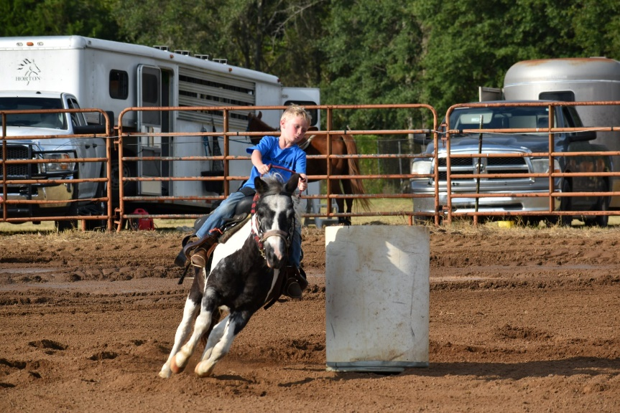
2020 Officers President – Jason Barrett
Vice President – Nikki Walker

Shows are held at
Grady County Saddle Club – Cairo
Irwin County Saddle Club – Ocilla
Tift County Saddle Club - Tifton

